
Year 7
Term 3 Test – Version 2
No calculator , One A4 page of notes /43
Name: Date:

- Link the terms to the correct definition (5 marks)
Use the words mean, median, mode, range and outlier to fill in the blanks
The ___________ is the most common number

The ____________ is the average

An _____________ is a piece of data is much smaller or larger than most of the other data

The difference between largest and lowest is called the ____________

___________ is the middle number of ordered data

- Solve the following (6 marks)

- $5+8=$ | - $-3+7=$
- $6+ -3=$ | - $-7-3=$
 | 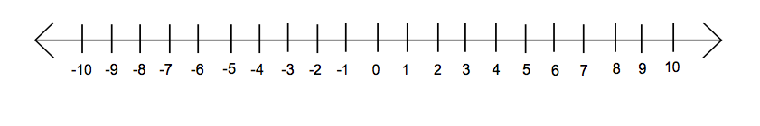

- Solve the Linear equations showing full working (8 marks)
- $2b=12$ | - $14+y=34$
- $3w-12=18$ | - $r-5=15$
- $2y+7=19$ | - $x÷5=4$

- Solve the following problems showing full working out (6 marks)

- $5^{2}$

- $8^{2}$

- $\sqrt{9}$

- $\sqrt{100}$

- $2^{3}$

- $3^{3}$

- Complete the factor tree below and use this to write down the prime factors of 100 (5 marks)

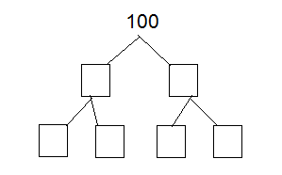

100=________________

- Answer the following questions using the data below (4 marks)
(hint: put the numbers in order)

58, 64, 53, 82, 77, 57,109, 68, 72, 64

Determine the range________________________

Determine the mode________________________

Determine the outlier_______________________

Determine the median______________________

- Write an equation for the following (3 marks)

a) When a number is added to five the answer is seven

b) When a number is multiplied by three and then five is taken from it, it equals thirteen

- The area of a rectangular garden is $12m^{2}$. The length of the garden bed is 4m and the width is unknown and represented with a w. (3 marks)

- What is the formula for the area of a rectangle?

- Draw a picture of the rectangle and label the width w.

- Complete the equation ____m ×_____m = $12m^{2}$

- What is the width of the garden bed? (what does w equal?)

- Trevor works at a car yard and earns $300 per week plus $20 for every car he sells.

- If Trevor sells one car how much money will he make?

- If Trevor sells two cars how much money will he make?

- Write an equation to represent how much money Trevor earns let n represent the number of cars.

- If Trevor makes $420 in a week, how many cars will he need to sell?

